1. echo
Meaning: Displays text or variable values on the screen. It sends the selected text or the current value of a variable to the terminal, making information visible to the user.
Use: Used to print messages and display information. It is commonly used in shell scripts to show instructions, results, variable values, or simple status messages to the person using the terminal.
Options:
-n — Does not print a new line at the end.
-e — Enables interpretation of special characters
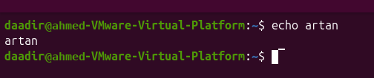

2. history
Meaning: Displays the list of previously used commands. The list is kept by the shell during your session and may also be saved in a history file, depending on the shell settings.
Use: Used to view and reuse commands you entered before. This is helpful when you want to repeat a long command, check what you ran earlier, or find a command without typing it again.
Keyboard shortcuts:
Ctrl + R — Searches backward through previous commands.
↑ — Shows the previous command.
↓ — Moves forward through command history.
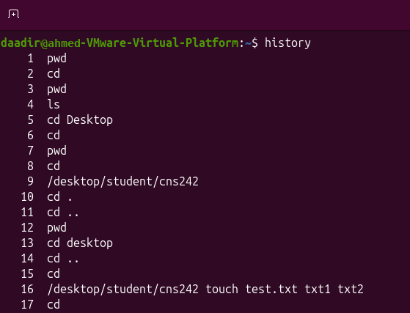

3. pwd
Meaning: Short for Print Working Directory. The command name describes its task: it prints the working directory path, which tells you your current location in the filesystem.
Use: Displays the full path of the current directory. Run it whenever you need to confirm which folder the terminal is currently working in, especially before creating, moving, or deleting files.
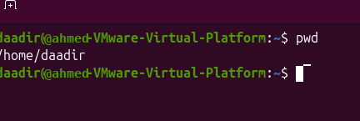

4. cd
Meaning: Short for Change Directory. The name describes its purpose: changing the shell’s current working directory to another location.
Use: Used to move from one directory to another. It helps you navigate the Linux folder structure so that relative commands operate in the directory you intend.
Special forms:
cd ~ — Goes to the user's home directory.
cd — Also goes to the home directory.
cd .. — Moves one level up to the parent directory.
cd - — Returns to the previous directory.
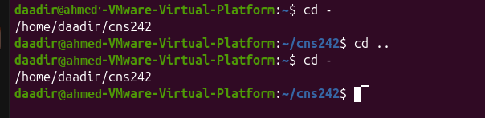

5. ls
Meaning: Short for List. It provides a directory listing so you can see the names of files and folders stored in a location.
Use: Displays files and directories. Use it to inspect the contents of the current folder or a directory you specify before opening or managing its files.

Options:
-a — Displays all files, including hidden files.
--all — Long form of -a.
-l — Displays files in long format with details.
--format=long — Long-format listing.
-h — Displays file sizes in human-readable units such as K, M, and G.
--human-readable — Long form of -h.

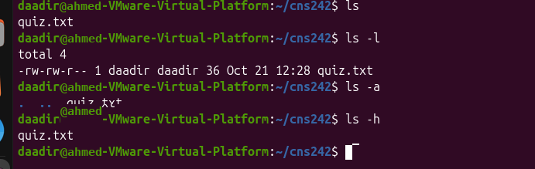

6. touch
Meaning: Creates an empty file or updates the time of an existing file. If the named file does not exist, it creates it without adding content; if it already exists, it updates its timestamps.
Use: Used to create new empty files. It is useful when preparing a file for later editing or when a script needs to ensure that a file exists.

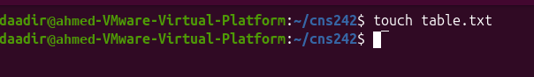

7. mkdir
Meaning: Short for Make Directory. It creates a new directory entry in the filesystem, giving you a place to organize related files and folders.
Use: Creates new directories (folders). Use it to organize work into separate folders, for example by creating directories for assignments, projects, or documents.
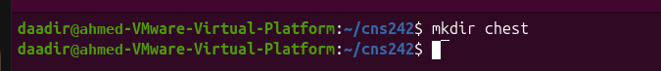

8. rmdir
Meaning: Short for Remove Directory. It is intended for removing directories that contain no files or subdirectories.
Use: Removes empty directories. Use it to clean up folders that are no longer needed; it will not normally remove a directory that still contains items.

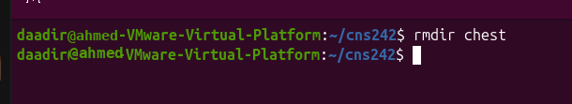

cp
Meaning: Short for Copy. It makes a separate copy of the selected source, leaving the original in its original location.
Use: Copies files or directories from one location to another. Use it to make backups, duplicate documents, or place files in another folder while keeping the original source.

Options:
-r — Copies directories and everything inside them recursively.
--recursive — Long form of -r.
-i — Asks before overwriting an existing file.
--interactive — Long form of -i.

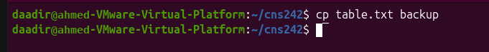

10. mv
Meaning: Short for Move. It changes a file or directory’s location; when the source and destination are in the same directory, it can be used to rename it.
Use: Moves files to another directory or renames files. Use it to organize files into the correct folders or give a file a clearer name without creating a second copy.

Option:
-i — Asks before overwriting an existing file.
--interactive — Long form of -i.

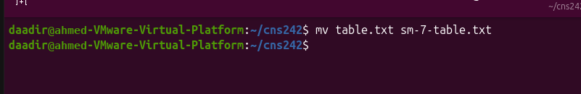

11. rm
Meaning: Short for Remove. It removes the specified filesystem entries, so it should be used carefully because deleted files may not be easy to recover.
Use: Deletes files and directories. Use it to remove unwanted items from the filesystem; verify the path and options first because this command can permanently delete data.

Options:
-i — Asks for confirmation before deleting each file.
--interactive — Long form of -i.
-r — Removes directories and everything inside them recursively.
--recursive — Long form of -r.
-f — Forces removal without asking questions.
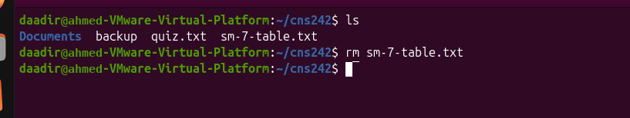

12. man
Meaning: Short for Manual. It opens the system’s reference documentation for a command, including its description, syntax, and available options.
Use: Displays the manual page for a command. Use it when you need the official local reference for command syntax, descriptions, and options before running an unfamiliar command.

Keyboard controls :
Space — Moves to the next page.
b — Moves back one page.
/word — Searches for a word.
n — Finds the next match.
q — Quits the manual page.

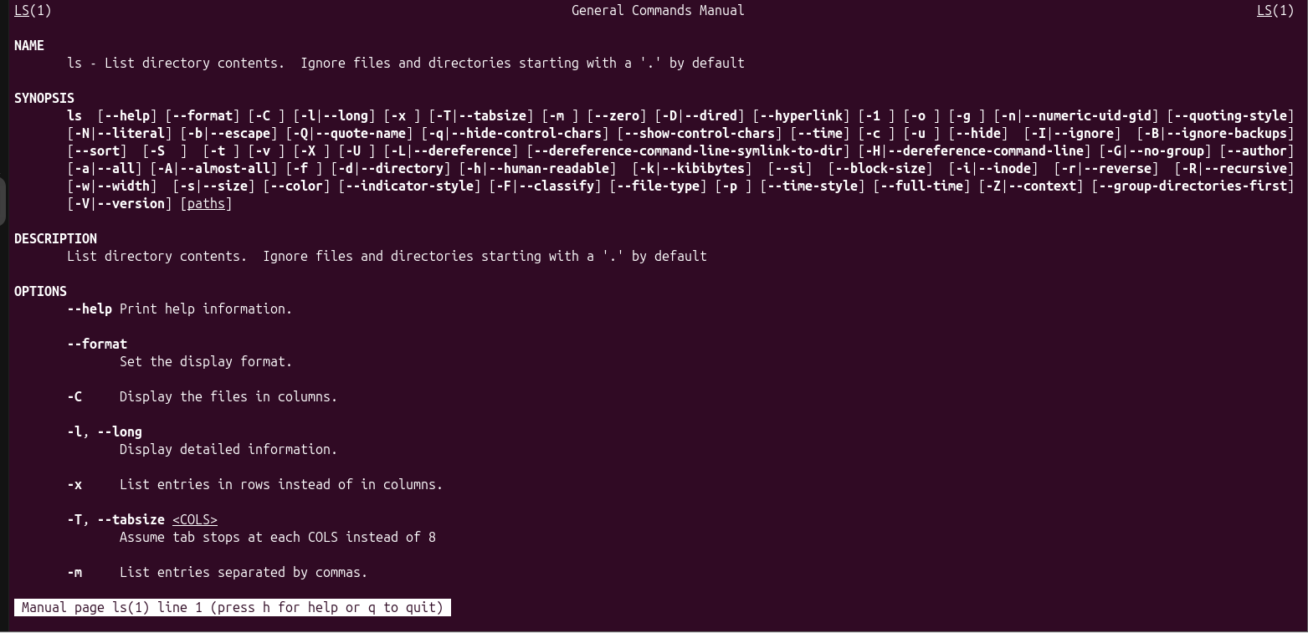

13. info
Meaning: Displays detailed GNU documentation. It opens the GNU Info documentation system, which can organize related topics into sections and navigable pages.
Use: Used to read longer documentation about commands and tools. Use it when you need more detailed GNU documentation or want to move between related documentation topics.
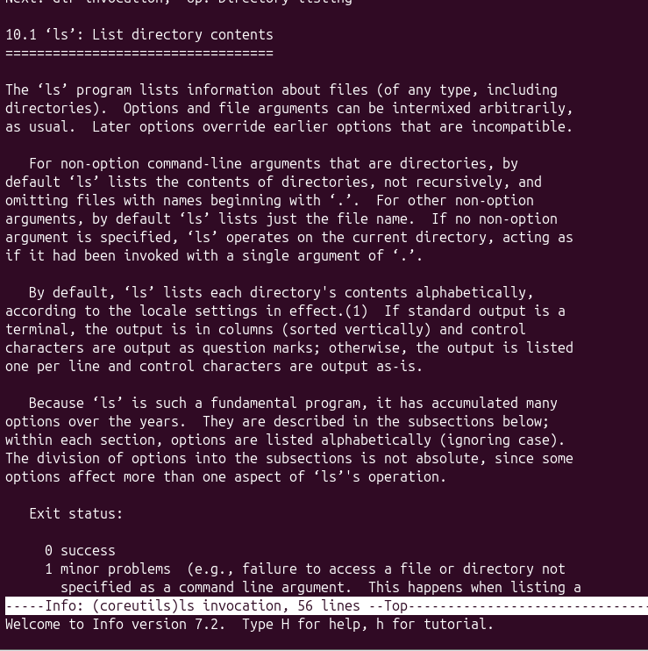

14. help
Meaning: Displays help information about Bash built-in commands. The information usually explains the command’s purpose and the syntax or options that Bash supports.
Use: Used to get information about commands built into Bash, such as cd. Use it when you need a quick explanation of a Bash built-in without opening a separate manual page.

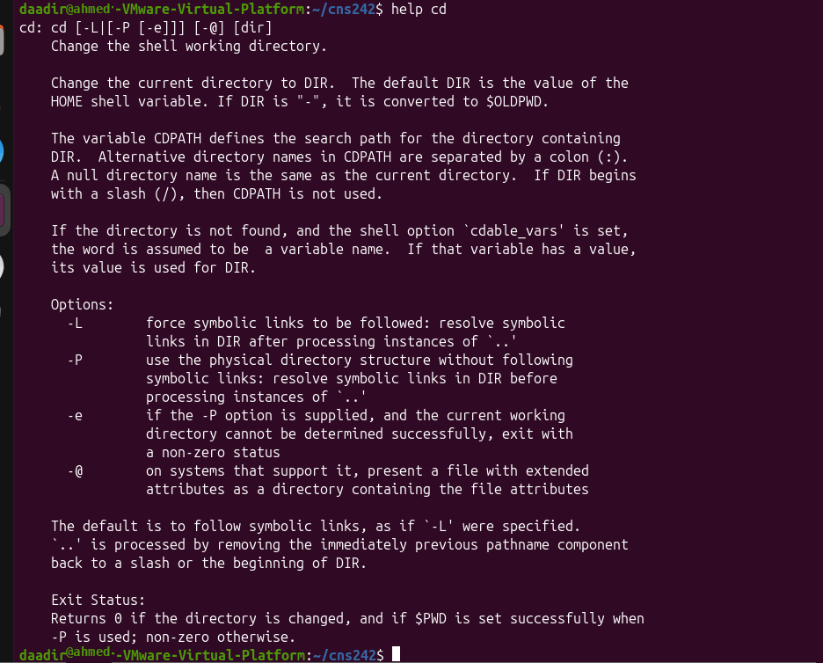

16. export
Meaning: Makes a shell variable available to programs started from that shell. An exported variable becomes part of the environment inherited by child processes launched from the current shell.
Use: Used to pass a variable into the environment. Use it when a program or script launched from the current shell needs to read a variable that you have set.

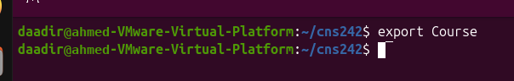

17. echo $SHELL
Meaning: Displays the shell being used. It prints the value stored in the SHELL environment variable, which normally identifies the user’s configured login shell.
Use: Used to check which shell is running. Use it to inspect the configured shell information when troubleshooting shell behavior or checking your environment.
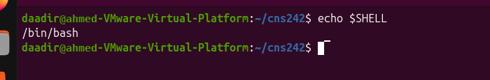

18. echo $PATH
Meaning: Displays the directories stored in the PATH variable. The value is a list of directory paths, usually separated by colons, that the shell checks when looking for executable commands.
Use: Used to see where Bash searches for programs. Use it to diagnose why a command cannot be found or to check whether the directory containing a program is included in PATH.

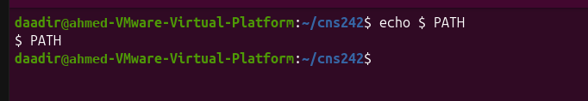

19. sudo apt install
Meaning: Installs software packages on Ubuntu. It uses Ubuntu’s APT package manager to download and install a named package and handle its required dependencies.
Use: Used to install a program from the package repositories. Use it when you need to add software through Ubuntu’s package system; package installation may require administrator privileges.

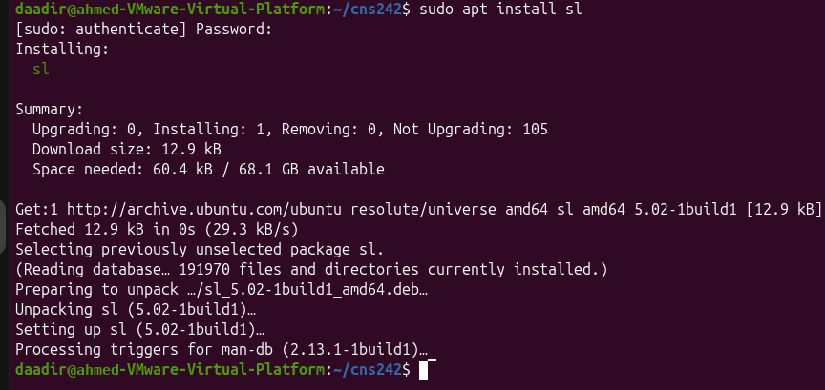

20. cat
Meaning: Short for Concatenate. The name refers to joining data together; the command can also read and display the contents of one or more files.
Use: Displays the contents of text files and combines multiple files. Use it to quickly read a small text file in the terminal or join the contents of several files into one stream.

Option
-n — Adds line numbers to the output.
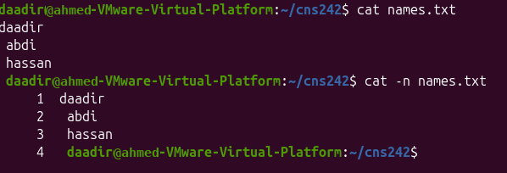

21. less
Meaning: A file pager. A pager is a terminal program that lets you inspect text in manageable screen-sized sections instead of printing the entire file at once.
Use: Displays long text files one screen at a time. You can move forward, backward, and search without modifying the file. Use it to inspect large files, configuration files, or logs comfortably while keeping the original file unchanged.
Keyboard controls :
Space — Moves forward one page.
b — Moves backward one page.
/word — Searches for a word.
n — Finds the next match.
q — Quits.
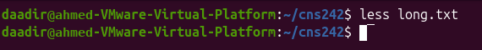

22. more
Meaning: A file pager. A pager is a terminal program that lets you inspect text in manageable screen-sized sections instead of printing the entire file at once.
Use: Displays a long file one screen at a time. Use it when a file is too long to fit on one terminal screen and you want to read it page by page.
Keyboard controls:
Space — Moves to the next page.
q — Quits.
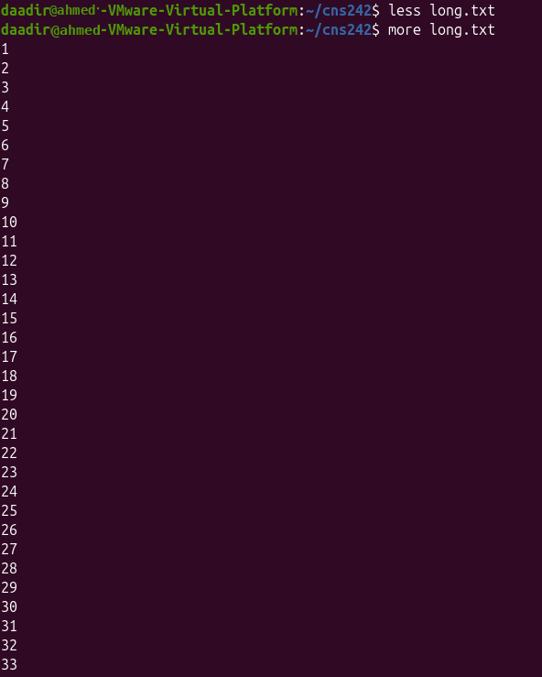

23. head
Meaning: Displays the beginning of a file. It reads a file and prints its opening portion, which is useful when you only need to inspect the first part of a document or output.
Use: Shows the first lines of a text file. By default, it displays 10 lines. Use it to preview the start of a file or check the opening entries of a log without displaying the whole file.
Option:
- n — Specifies the number of lines to display.
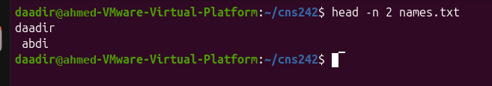

24. tail
Meaning: Displays the end of a file. It reads a file and prints its final portion, which is useful for checking the newest entries in log files.
Use: Shows the last lines of a text file. By default, it displays 10 lines. Use it to inspect the most recent entries in a log or check the ending section of a text file.
Options:
-n — Specifies the number of lines to display.
-f — Follows a file and displays new lines as they are added.
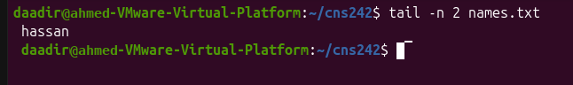

25. file
Meaning: Identifies the actual file type. It examines information about the file’s contents rather than trusting only the extension in its filename.
Use: Checks the real type of a file instead of relying only on its filename extension. Use it when a file has an unclear or misleading extension and you need to identify the format before opening it.

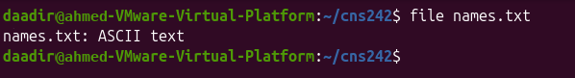

26. stat
Meaning: Displays file status information. It reports technical details recorded by the filesystem about the selected file or directory.
Use: Shows detailed file metadata, such as size, permissions, owner, and timestamps. Use it to investigate file properties, confirm when a file was changed, or check ownership and permissions.
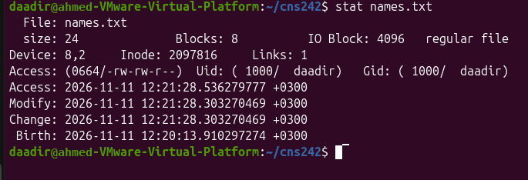

27. ls -l
Meaning: Lists files in long format. Each entry is shown with extra columns rather than only its name, making the listing useful for checking file details.
Use: Displays basic file information, including permissions, owner, size, and modification time. Use it when reviewing directory contents and you need to compare permissions, ownership, file sizes, or modification dates.
Option:
-l — Displays a detailed listing, with one line per entry.

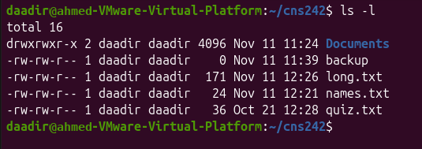

28. which
Meaning: Locates an executable command. It reports the path of an executable found by searching the directories listed in the PATH environment variable.
Use: Searches directories in the PATH variable to find the location of an executable program. Use it to check which executable will be found for a command name and where that executable is stored.

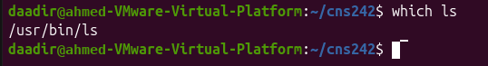

29. type
Meaning: Identifies the type of a command. It helps explain what will run when you enter a command name in the shell.
Use: Determines whether a command is a shell built-in, executable file, alias, or function. Use it to understand why a command behaves a certain way and whether it is provided by the shell or by an external program.
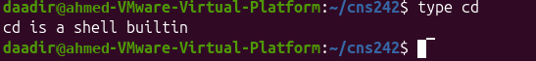

30. command -v
Meaning: Finds how a command is resolved by the shell. It reports the command interpretation or path that the shell would use for the supplied command name.
Use: Checks how the shell identifies a command. Use it to quickly determine whether a command is available and how the shell will run it.
-v — Displays how the shell resolves the command.
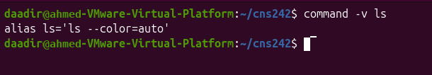

31. whereis
Meaning: Locates command-related files. It searches standard locations for related program files and documentation, rather than searching every file on the system.
Use: Finds the executable binary, source code, and manual pages associated with a command. Use it when you want to locate the main program file and related documentation installed on the system.
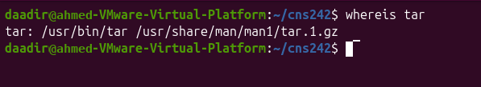

32. find

Meaning: Searches for files and directories. It can search from a chosen starting directory and apply conditions to narrow down the results.
Use: Finds files by name, type, size, modification time, and other conditions. Use it to locate a particular file, filter a large directory tree, or find files that meet specific conditions.

Options and search expressions:
-name — Searches using a filename pattern; matching is case-sensitive.
-iname — Searches using a filename pattern without case sensitivity.
-type f — Searches for regular files.
-type d — Searches for directories.
-size — Searches according to file size.
-mmin — Searches according to modification time in minutes.

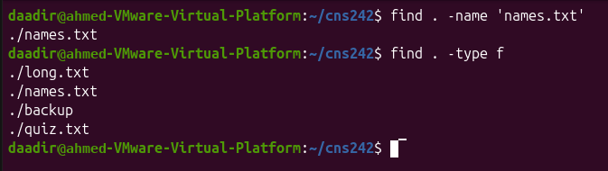

33. locate
Meaning: Searches for files and directories using a prebuilt database. Because it searches an index rather than checking every directory live, results can be quick but may be out of date until the database is refreshed.
Use: Finds file paths quickly without scanning the entire filesystem. Use it for quick filename searches when its database is available; refresh the database if recently added files are missing.

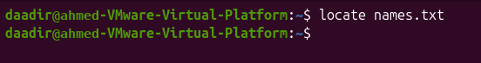

34. updatedb
Meaning: Updates the file-location database. It rebuilds or refreshes the index of file paths used by locate, subject to system permissions and configuration.
Use: Refreshes the database used by locate, so recently created files can appear in search results. Use it after adding or changing files when you want locate searches to include the latest filesystem paths; it may require administrator privileges.

35. grep
Meaning: Short for Global Regular Expression Print. The name describes its original role: printing lines that match a regular-expression pattern.
Use: Searches for specific text or patterns inside files and displays matching lines. Use it to find a word, phrase, or pattern in one file or many files, which is especially useful when searching configuration files and logs.
Option:
-n — Displays line numbers alongside matching lines.
-i — Ignores uppercase and lowercase differences.
-v — Displays lines that do not match the search pattern.
-r — Searches recursively inside directories and subdirectories.
-R — Searches recursively and follows directory symbolic links.
-n — Displays matching line numbers.
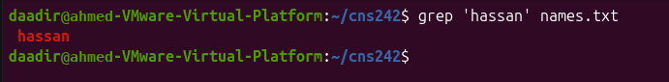

36. Redirection operators
These are operators, not commands.
>
Meaning: Redirects output into a file. The operator takes a command’s standard output and writes it to the named file; using it on an existing file normally replaces its contents.
Use: Creates a file or overwrites its existing contents. Use it to save command output to a file; remember that a single > replaces existing content, so use it carefully.
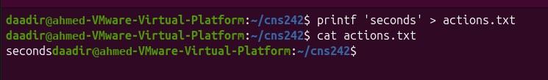
2>
Meaning: Redirects standard error (stderr). It sends diagnostic or error output to a file or another destination separately from normal standard output.
Use: Saves error messages into a separate file. Use it when you want to keep error output for troubleshooting without mixing it with normal program results.

<
Meaning: Redirects input from a file. It makes a command read its standard input from the specified file instead of waiting for input from the keyboard.
Use: Sends file contents to a command as standard input. Use it when a command expects input and you want that input to come from a saved file rather than typing it manually.
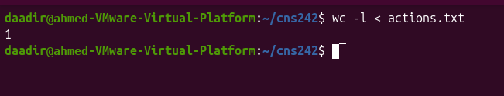
|
Meaning: Pipe operator. The vertical bar connects commands so that the output produced by the command on the left becomes input for the command on the right.
Use: Sends the output of one command directly into another command. Use it to build command pipelines, such as listing files and then filtering the list with another command.
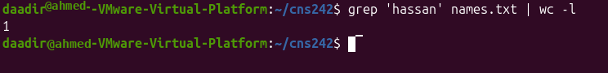

37. Command chaining operators
These operators control how commands execute.
— Runs the next command regardless of whether the previous command succeeds or fails.
&& — Runs the next command only if the previous command succeeds.
|| — Runs the next command only if the previous command fails.

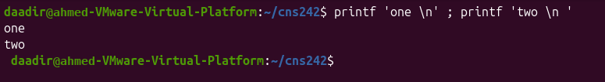

38. sort
Meaning: Arranges lines of text in order. It reads lines from input and outputs them in a chosen order, with options available for numeric or reverse sorting.
Use: Sorts text alphabetically or sorts numbers numerically. Use it to arrange records into a consistent order before reading, comparing, or processing them with other commands.

Options:
-n — Sorts numbers according to their numeric values.
-r — Reverses the sorting order.

39. uniq
Meaning: Removes repeated adjacent lines. It compares neighboring lines and suppresses or reports repetitions; identical lines usually need to be next to each other to be treated as duplicates.
Use: Removes consecutive duplicate lines. Usually used with sort to group duplicates first. Use it to clean repeated entries from text; combining it with sort helps bring identical lines together first.

Options:
-c — Counts repeated adjacent lines and displays the count.
-d — Displays only duplicate lines.
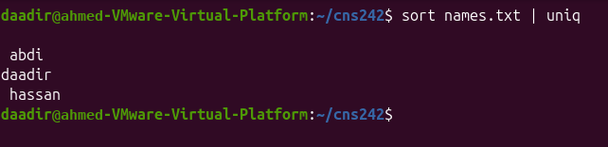

40. cut
Meaning: Extracts selected parts of each line. It selects chosen fields or character positions from each input line, allowing you to isolate only the information you need.
Use: Extracts information using delimiters, fields, or character positions. Use it to select columns from structured text, such as values separated by commas, tabs, or another delimiter.
Options:
-d — Specifies the delimiter used to separate fields.
-f — Selects which fields to display.
-c — Selects specific character positions.
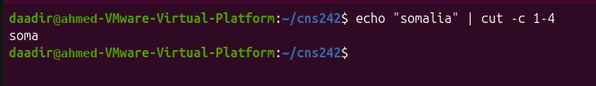

41. paste
Meaning: Combines corresponding lines from multiple files. It reads input files line by line and places corresponding lines together in a combined output.
Use: Joins information from two or more files side by side. Use it when related files have corresponding lines and you want to view or combine those lines in one output.

Options:
-d — Changes the separator between combined columns.
-s — Combines lines from each input file serially into one row.

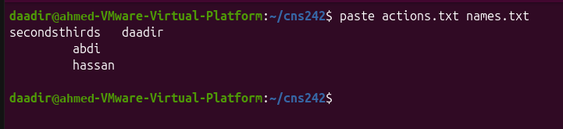

42. wc
Meaning: Short for Word Count. Despite its name, it can count more than words, including lines and bytes, depending on the option used.
Use: Counts lines, words, and bytes in a file or command output. Use it to measure the size of text, check how many lines a file contains, or count words in an assignment.
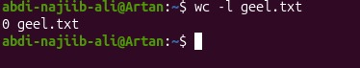
Options:
-l — Counts lines.
-w — Counts words.
-c — Counts bytes.

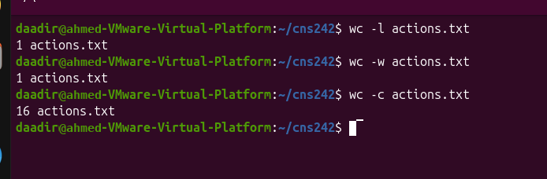

43. bzip2
Meaning: Compresses files using bzip2 compression. It applies the bzip2 compression method and normally creates a compressed file with a .bz2 extension.
Use: Reduces the size of individual files. Use it to save storage space or prepare files for transfer; decompression is needed before using the original content normally.

Option:
- -k — Keeps the original file after compression.

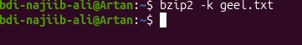

44. Process commands
A process is a program that is currently running on Linux.

1. ps — Process Status
Options:
-f — Shows full details, including the owner, PPID, and start time.
-p PID — Displays only the process with the specified PID.
-o COLS — Displays only the columns you choose.
-e — Displays every process.
-a and -u — Used with ps aux to display processes from all users with CPU and memory information.

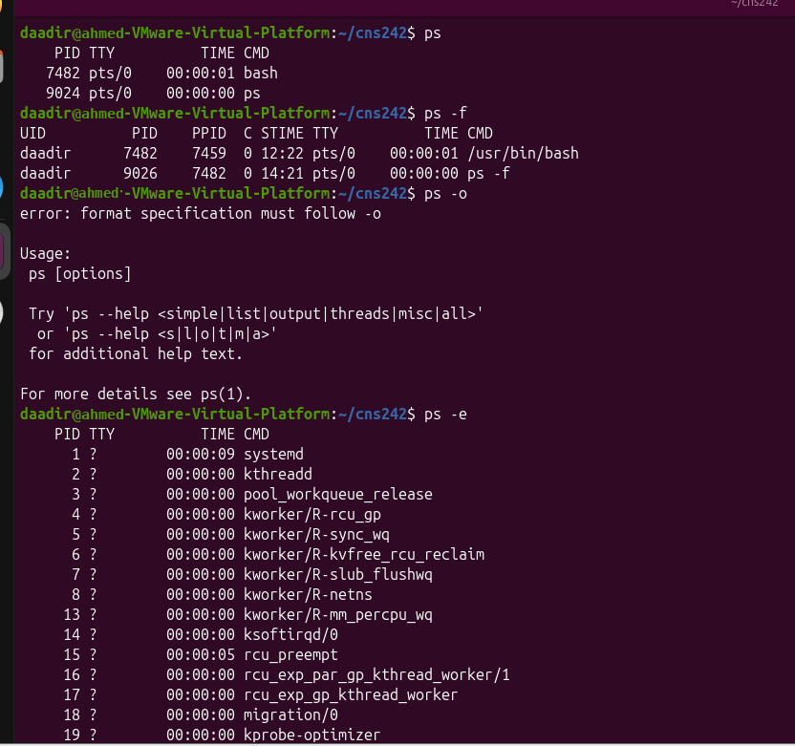

45. pstree — Process Tree
Meaning: Displays processes in a tree, showing parent and child relationships. The tree layout makes it easier to understand which process started another process and how running tasks are related.

Option:
- -p — Displays PIDs beside process names.

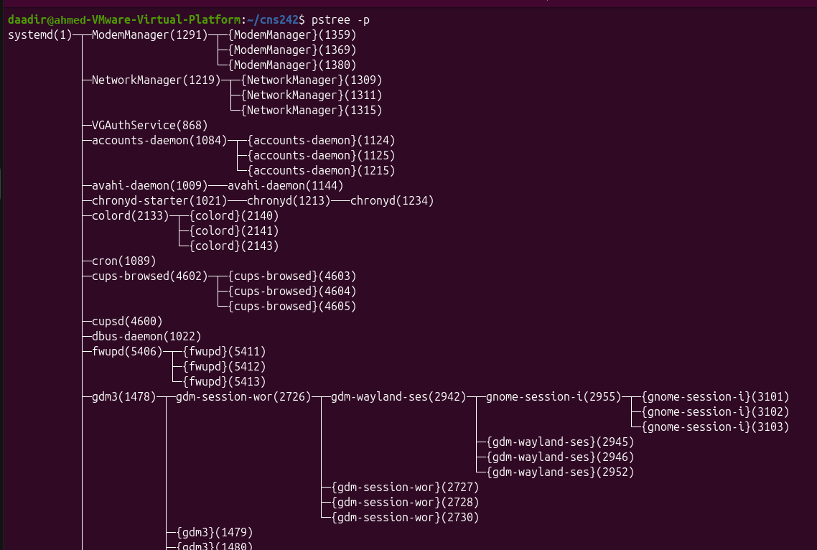

46. top — Live Process Monitor
Meaning: Displays running processes and updates the information continuously. It refreshes process information repeatedly, allowing you to monitor resource use and activity while programs are running.

Option:
- -u USER — Displays only processes belonging to the specified user.

47. htop — Interactive Process Monitor
Meaning: Displays processes in a more visual and interactive way than top. It provides an interactive terminal interface for viewing processes and, where permitted, managing them.
Options:
-u USER — Displays only the specified user's processes.
-t — Displays processes in tree view.

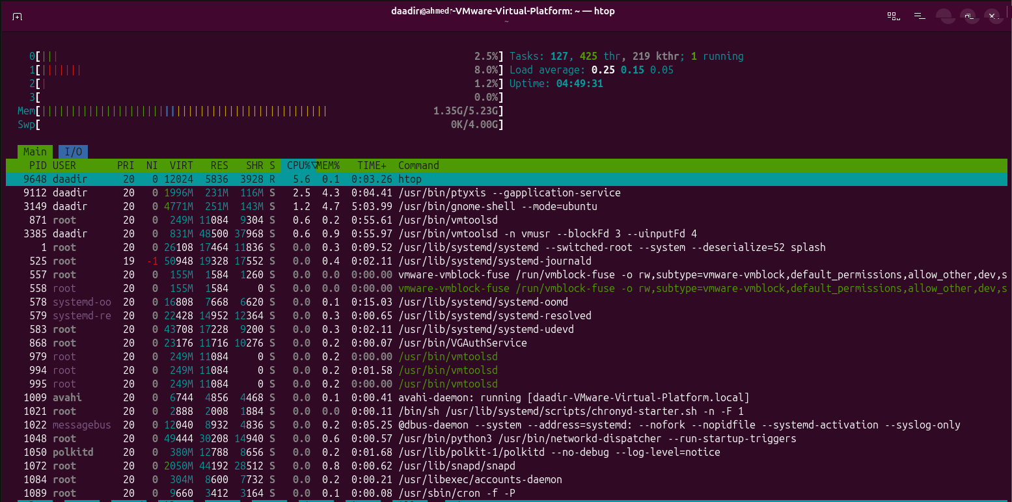

48. jobs — List Current Jobs
Meaning: Displays background and stopped jobs belonging to the current terminal. It lists jobs started from the current shell session, along with their running or stopped status.

Option:
- -l — Displays each job's PID.
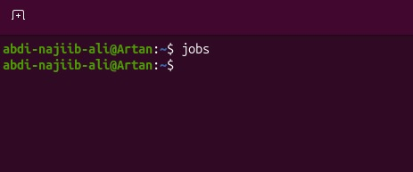

49. bg — Background
Meaning: Resumes a stopped job in the background. The job continues running without occupying the terminal for interactive input, allowing you to keep using the shell.

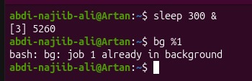

50. fg — Foreground
Meaning: Brings a background or stopped job back to the foreground. The selected job becomes the active terminal job and can receive keyboard input.



51. kill — Send a Signal to a Process
Meaning: Sends a signal to a process using its PID or job number. The signal tells the operating system or target process to perform an action, such as requesting a normal shutdown or forcing termination.

Options and arguments:
-TERM — Sends SIGTERM, asking the process to finish normally.
-HUP — Sends SIGHUP; many services use it to reload configuration.
-9 — Sends SIGKILL, forcing the process to end.
-l — Lists signal names; kill -l 15 displays the name for signal 15.
%N — Identifies a job by its job number.

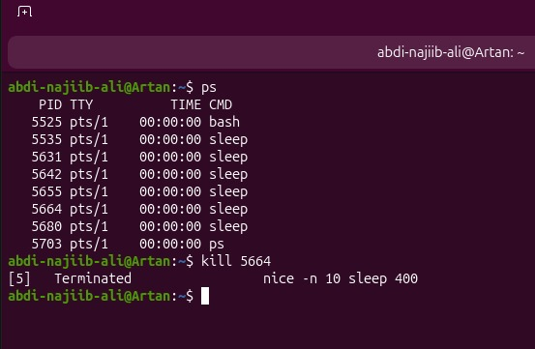

52. pkill — Stop Processes by Name
Meaning: Sends a signal to processes matching a name. It selects processes by their names, so you do not need to look up each process ID individually.
Option:
- -u USER — Selects processes belonging to the specified user.

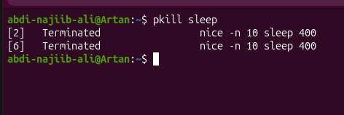

53. killall — Stop Processes by Exact Name
Meaning: Sends a signal to processes with the specified exact name. It is useful when several processes share a known process name; check the target carefully before sending a signal.

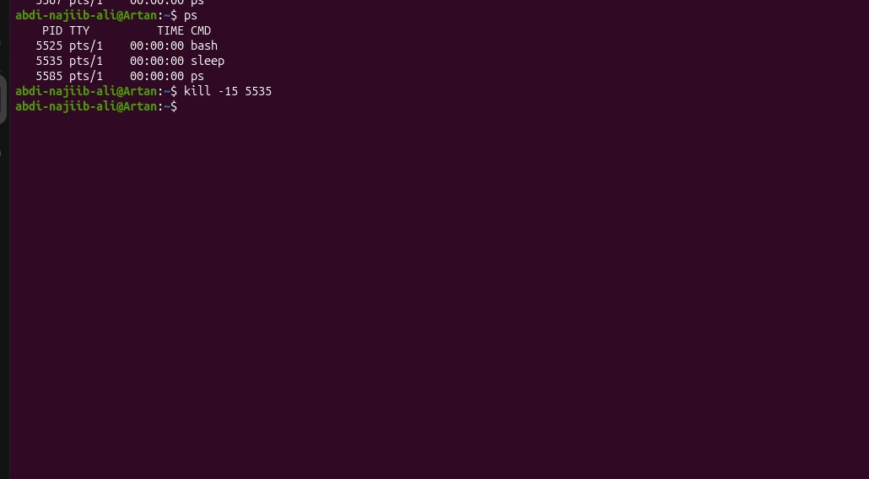

54. nice — Start a Process with a Priority
Meaning: Starts a process with a selected niceness value. The niceness value influences the process’s scheduling priority relative to other processes; it does not directly set a fixed CPU percentage.

Option:
- -n N — Sets the niceness value when starting the process.



